Simple Exonential Smoothing and ARIMA time series

sammy waiyaki

5/13/2020

## R Markdown

### Reading Data

TSData <- read.csv(file.choose(), header = T)  
View(TSData)  
summary(TSData)

## Adj.Close   
## Min. :1269   
## 1st Qu.:2556   
## Median :4148   
## Mean :4402   
## 3rd Qu.:5876   
## Max. :9817

sum(is.na(TSData))

## [1] 0

std_deviation <-sqrt(var(TSData))  
std_deviation

## Adj.Close  
## Adj.Close 2101.419

### Visualizing Outliers using Boxplot

boxplot(TSData, main="Boxplot of Adjusted Clossing Prices")

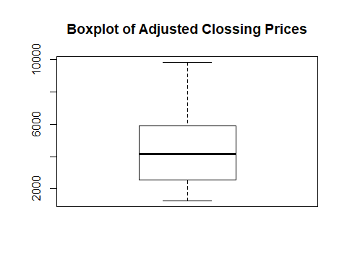 ### Transforming the data into time series

TSData <- ts(TSData)  
head(TSData, n=50)

## [1] 2609.63 2602.68 2504.65 2499.46 2440.51 2474.55 2488.52 2439.94  
## [9] 2478.30 2417.59 2394.59 2346.90 2340.02 2292.27 2316.41 2360.92  
## [17] 2326.20 2349.91 2358.06 2349.00 2389.86 2413.36 2382.85 2309.57  
## [25] 2278.75 2293.03 2304.85 2320.06 2320.04 2373.93 2332.54 2321.80  
## [33] 2306.20 2327.10 2299.78 2303.35 2327.48 2344.99 2353.78 2331.57  
## [41] 2271.48 2258.60 2260.28 2272.81 2220.50 2212.49 2169.34 2255.76  
## [49] 2243.87 2263.61

### Plotting the daily time series

plot.ts(TSData, main=" Daily Adj Close")

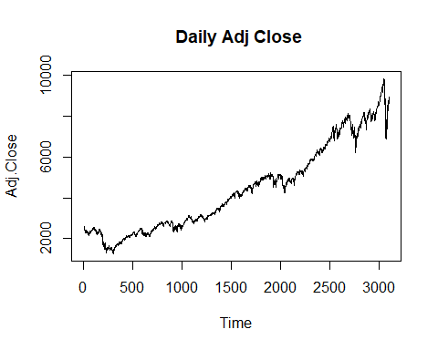

### Simple Moving Average Smoothing

library(TTR)

## Warning: package 'TTR' was built under R version 3.6.3

TSDataSMA3 <- SMA(TSData, n = 3)  
plot.ts(TSDataSMA3)

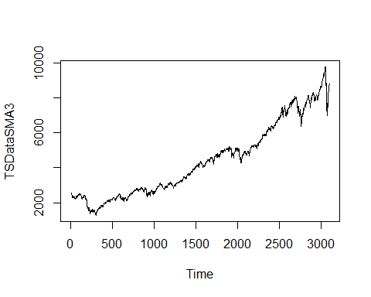

TSDataSMA6 <- SMA(TSData, n = 6)  
plot.ts(TSDataSMA6)

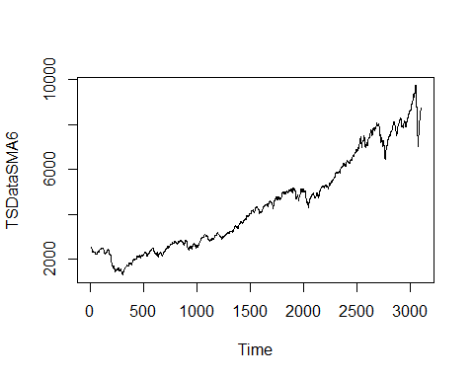

TSDataSMA10 <- SMA(TSData, n = 10)  
plot.ts(TSDataSMA10)

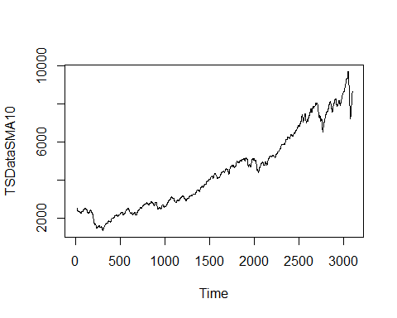 ###exponential smoothing

TSData_forecast <- HoltWinters(TSData, beta = F, gamma = F)  
TSData_forecast

## Holt-Winters exponential smoothing without trend and without seasonal component.  
##   
## Call:  
## HoltWinters(x = TSData, beta = F, gamma = F)  
##   
## Smoothing parameters:  
## alpha: 0.8330693  
## beta : FALSE  
## gamma: FALSE  
##   
## Coefficients:  
## [,1]  
## a 8651.811

summary(TSData_forecast)

## Length Class Mode   
## fitted 6202 mts numeric   
## x 3102 ts numeric   
## alpha 1 -none- numeric   
## beta 1 -none- logical   
## gamma 1 -none- logical   
## coefficients 1 -none- numeric   
## seasonal 1 -none- character  
## SSE 1 -none- numeric   
## call 4 -none- call

plot(TSData_forecast)

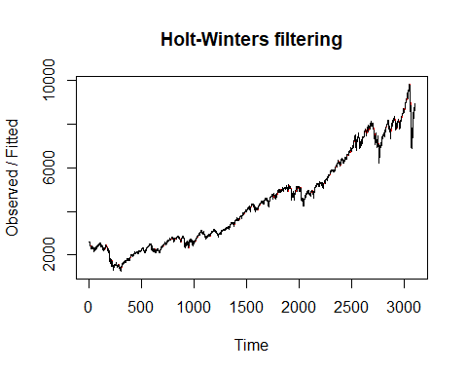 ### Forecasting Using SES

library(forecast)

## Warning: package 'forecast' was built under R version 3.6.3

## Registered S3 method overwritten by 'quantmod':  
## method from  
## as.zoo.data.frame zoo

TSData_forecast1 <- forecast(TSData_forecast, h=300)  
TSData_forecast1

## Point Forecast Lo 80 Hi 80 Lo 95 Hi 95  
## 3103 8651.811 8569.367 8734.255 8525.724 8777.898  
## 3104 8651.811 8544.507 8759.115 8487.704 8815.919  
## 3105 8651.811 8524.409 8779.213 8456.967 8846.656  
## 3106 8651.811 8507.075 8796.547 8430.457 8873.166  
## 3107 8651.811 8491.606 8812.016 8406.799 8896.823  
## 3108 8651.811 8477.505 8826.118 8385.233 8918.390  
## 3109 8651.811 8464.462 8839.161 8365.285 8938.338  
## 3110 8651.811 8452.269 8851.353 8346.638 8956.985  
## 3111 8651.811 8440.780 8862.843 8329.067 8974.556  
## 3112 8651.811 8429.885 8873.738 8312.404 8991.219  
## 3113 8651.811 8419.500 8884.123 8296.522 9007.101  
## 3114 8651.811 8409.560 8894.063 8281.320 9022.303  
## 3115 8651.811 8400.012 8903.610 8266.718 9036.905  
## 3116 8651.811 8390.813 8912.809 8252.649 9050.973  
## 3117 8651.811 8381.928 8921.695 8239.060 9064.562  
## 3118 8651.811 8373.326 8930.297 8225.904 9077.718  
## 3119 8651.811 8364.981 8938.641 8213.143 9090.480  
## 3120 8651.811 8356.873 8946.750 8200.742 9102.880  
## 3121 8651.811 8348.982 8954.641 8188.674 9114.949  
## 3122 8651.811 8341.291 8962.332 8176.911 9126.711  
## 3123 8651.811 8333.786 8969.836 8165.434 9138.189  
## 3124 8651.811 8326.454 8977.168 8154.221 9149.402  
## 3125 8651.811 8319.284 8984.338 8143.255 9160.368  
## 3126 8651.811 8312.265 8991.357 8132.521 9171.102  
## 3127 8651.811 8305.389 8998.234 8122.004 9181.619  
## 3128 8651.811 8298.646 9004.977 8111.692 9191.931  
## 3129 8651.811 8292.030 9011.593 8101.573 9202.050  
## 3130 8651.811 8285.533 9018.090 8091.636 9211.986  
## 3131 8651.811 8279.149 9024.474 8081.873 9221.749  
## 3132 8651.811 8272.873 9030.750 8072.275 9231.348  
## 3133 8651.811 8266.699 9036.924 8062.833 9240.790  
## 3134 8651.811 8260.623 9043.000 8053.540 9250.083  
## 3135 8651.811 8254.639 9048.984 8044.389 9259.234  
## 3136 8651.811 8248.744 9054.878 8035.374 9268.249  
## 3137 8651.811 8242.935 9060.688 8026.488 9277.134  
## 3138 8651.811 8237.206 9066.416 8017.728 9285.895  
## 3139 8651.811 8231.556 9072.066 8009.086 9294.536  
## 3140 8651.811 8225.981 9077.642 8000.560 9303.063  
## 3141 8651.811 8220.478 9083.145 7992.143 9311.479  
## 3142 8651.811 8215.044 9088.579 7983.833 9319.790  
## 3143 8651.811 8209.677 9093.946 7975.625 9327.998  
## 3144 8651.811 8204.374 9099.249 7967.515 9336.108  
## 3145 8651.811 8199.133 9104.489 7959.500 9344.122  
## 3146 8651.811 8193.953 9109.670 7951.577 9352.046  
## 3147 8651.811 8188.830 9114.792 7943.743 9359.880  
## 3148 8651.811 8183.763 9119.859 7935.994 9367.629  
## 3149 8651.811 8178.751 9124.871 7928.328 9375.294  
## 3150 8651.811 8173.791 9129.831 7920.743 9382.880  
## 3151 8651.811 8168.883 9134.740 7913.235 9390.387  
## 3152 8651.811 8164.023 9139.600 7905.804 9397.819  
## 3153 8651.811 8159.212 9144.411 7898.445 9405.178  
## 3154 8651.811 8154.447 9149.176 7891.158 9412.465  
## 3155 8651.811 8149.727 9153.896 7883.939 9419.683  
## 3156 8651.811 8145.051 9158.572 7876.788 9426.834  
## 3157 8651.811 8140.418 9163.205 7869.703 9433.920  
## 3158 8651.811 8135.827 9167.796 7862.681 9440.942  
## 3159 8651.811 8131.276 9172.347 7855.721 9447.902  
## 3160 8651.811 8126.764 9176.858 7848.821 9454.802  
## 3161 8651.811 8122.291 9181.332 7841.980 9461.643  
## 3162 8651.811 8117.855 9185.767 7835.196 9468.426  
## 3163 8651.811 8113.456 9190.166 7828.469 9475.154  
## 3164 8651.811 8109.093 9194.530 7821.795 9481.827  
## 3165 8651.811 8104.764 9198.858 7815.175 9488.447  
## 3166 8651.811 8100.470 9203.153 7808.607 9495.015  
## 3167 8651.811 8096.208 9207.414 7802.090 9501.533  
## 3168 8651.811 8091.979 9211.643 7795.622 9508.000  
## 3169 8651.811 8087.782 9215.840 7789.203 9514.419  
## 3170 8651.811 8083.616 9220.007 7782.831 9520.791  
## 3171 8651.811 8079.480 9224.143 7776.506 9527.117  
## 3172 8651.811 8075.374 9228.249 7770.226 9533.397  
## 3173 8651.811 8071.296 9232.326 7763.990 9539.632  
## 3174 8651.811 8067.248 9236.375 7757.798 9545.824  
## 3175 8651.811 8063.227 9240.396 7751.649 9551.974  
## 3176 8651.811 8059.233 9244.390 7745.541 9558.081  
## 3177 8651.811 8055.266 9248.356 7739.474 9564.148  
## 3178 8651.811 8051.325 9252.297 7733.447 9570.175  
## 3179 8651.811 8047.410 9256.212 7727.460 9576.163  
## 3180 8651.811 8043.521 9260.102 7721.511 9582.112  
## 3181 8651.811 8039.656 9263.967 7715.600 9588.023  
## 3182 8651.811 8035.815 9267.808 7709.726 9593.897  
## 3183 8651.811 8031.998 9271.625 7703.888 9599.735  
## 3184 8651.811 8028.204 9275.419 7698.086 9605.536  
## 3185 8651.811 8024.433 9279.189 7692.319 9611.303  
## 3186 8651.811 8020.685 9282.938 7686.587 9617.036  
## 3187 8651.811 8016.959 9286.664 7680.888 9622.734  
## 3188 8651.811 8013.255 9290.368 7675.223 9628.400  
## 3189 8651.811 8009.572 9294.051 7669.590 9634.032  
## 3190 8651.811 8005.910 9297.713 7663.990 9639.633  
## 3191 8651.811 8002.268 9301.354 7658.421 9645.202  
## 3192 8651.811 7998.647 9304.975 7652.883 9650.740  
## 3193 8651.811 7995.046 9308.576 7647.376 9656.247  
## 3194 8651.811 7991.465 9312.158 7641.898 9661.724  
## 3195 8651.811 7987.903 9315.720 7636.451 9667.172  
## 3196 8651.811 7984.359 9319.263 7631.032 9672.591  
## 3197 8651.811 7980.835 9322.788 7625.642 9677.981  
## 3198 8651.811 7977.329 9326.293 7620.280 9683.343  
## 3199 8651.811 7973.841 9329.781 7614.946 9688.677  
## 3200 8651.811 7970.371 9333.251 7609.639 9693.984  
## 3201 8651.811 7966.919 9336.704 7604.359 9699.264  
## 3202 8651.811 7963.484 9340.139 7599.105 9704.517  
## 3203 8651.811 7960.066 9343.557 7593.878 9709.745  
## 3204 8651.811 7956.664 9346.958 7588.676 9714.947  
## 3205 8651.811 7953.280 9350.343 7583.499 9720.123  
## 3206 8651.811 7949.911 9353.711 7578.348 9725.275  
## 3207 8651.811 7946.559 9357.063 7573.221 9730.401  
## 3208 8651.811 7943.223 9360.400 7568.119 9735.504  
## 3209 8651.811 7939.902 9363.721 7563.040 9740.583  
## 3210 8651.811 7936.597 9367.026 7557.985 9745.638  
## 3211 8651.811 7933.306 9370.316 7552.953 9750.670  
## 3212 8651.811 7930.031 9373.591 7547.944 9755.679  
## 3213 8651.811 7926.771 9376.852 7542.958 9760.665  
## 3214 8651.811 7923.525 9380.097 7537.994 9765.629  
## 3215 8651.811 7920.294 9383.329 7533.052 9770.571  
## 3216 8651.811 7917.077 9386.546 7528.132 9775.491  
## 3217 8651.811 7913.874 9389.749 7523.233 9780.390  
## 3218 8651.811 7910.684 9392.938 7518.355 9785.267  
## 3219 8651.811 7907.509 9396.114 7513.499 9790.124  
## 3220 8651.811 7904.347 9399.276 7508.663 9794.960  
## 3221 8651.811 7901.198 9402.425 7503.847 9799.776  
## 3222 8651.811 7898.062 9405.560 7499.051 9804.571  
## 3223 8651.811 7894.939 9408.683 7494.276 9809.347  
## 3224 8651.811 7891.830 9411.793 7489.520 9814.103  
## 3225 8651.811 7888.732 9414.890 7484.783 9818.840  
## 3226 8651.811 7885.648 9417.975 7480.065 9823.557  
## 3227 8651.811 7882.576 9421.047 7475.367 9828.256  
## 3228 8651.811 7879.516 9424.107 7470.687 9832.936  
## 3229 8651.811 7876.468 9427.155 7466.025 9837.597  
## 3230 8651.811 7873.432 9430.191 7461.382 9842.240  
## 3231 8651.811 7870.407 9433.215 7456.757 9846.866  
## 3232 8651.811 7867.395 9436.228 7452.150 9851.473  
## 3233 8651.811 7864.394 9439.229 7447.560 9856.063  
## 3234 8651.811 7861.404 9442.219 7442.988 9860.635  
## 3235 8651.811 7858.426 9445.197 7438.433 9865.190  
## 3236 8651.811 7855.458 9448.164 7433.895 9869.728  
## 3237 8651.811 7852.502 9451.120 7429.373 9874.249  
## 3238 8651.811 7849.557 9454.066 7424.869 9878.754  
## 3239 8651.811 7846.622 9457.000 7420.381 9883.242  
## 3240 8651.811 7843.698 9459.924 7415.909 9887.713  
## 3241 8651.811 7840.785 9462.838 7411.454 9892.169  
## 3242 8651.811 7837.882 9465.741 7407.014 9896.609  
## 3243 8651.811 7834.989 9468.633 7402.590 9901.033  
## 3244 8651.811 7832.107 9471.516 7398.182 9905.441  
## 3245 8651.811 7829.235 9474.388 7393.789 9909.834  
## 3246 8651.811 7826.372 9477.250 7389.411 9914.211  
## 3247 8651.811 7823.520 9480.103 7385.049 9918.574  
## 3248 8651.811 7820.677 9482.945 7380.702 9922.921  
## 3249 8651.811 7817.844 9485.778 7376.369 9927.254  
## 3250 8651.811 7815.021 9488.602 7372.051 9931.572  
## 3251 8651.811 7812.207 9491.415 7367.747 9935.875  
## 3252 8651.811 7809.403 9494.220 7363.458 9940.164  
## 3253 8651.811 7806.607 9497.015 7359.184 9944.439  
## 3254 8651.811 7803.822 9499.801 7354.923 9948.700  
## 3255 8651.811 7801.045 9502.578 7350.676 9952.947  
## 3256 8651.811 7798.277 9505.346 7346.443 9957.179  
## 3257 8651.811 7795.518 9508.105 7342.224 9961.399  
## 3258 8651.811 7792.768 9510.855 7338.018 9965.605  
## 3259 8651.811 7790.027 9513.596 7333.826 9969.797  
## 3260 8651.811 7787.294 9516.328 7329.647 9973.976  
## 3261 8651.811 7784.570 9519.052 7325.481 9978.142  
## 3262 8651.811 7781.855 9521.768 7321.328 9982.295  
## 3263 8651.811 7779.148 9524.474 7317.188 9986.434  
## 3264 8651.811 7776.450 9527.173 7313.061 9990.562  
## 3265 8651.811 7773.759 9529.863 7308.947 9994.676  
## 3266 8651.811 7771.077 9532.545 7304.845 9998.778  
## 3267 8651.811 7768.403 9535.219 7300.755 10002.867  
## 3268 8651.811 7765.738 9537.885 7296.678 10006.944  
## 3269 8651.811 7763.080 9540.543 7292.614 10011.009  
## 3270 8651.811 7760.430 9543.193 7288.561 10015.062  
## 3271 8651.811 7757.788 9545.835 7284.520 10019.102  
## 3272 8651.811 7755.153 9548.469 7280.491 10023.131  
## 3273 8651.811 7752.527 9551.096 7276.474 10027.148  
## 3274 8651.811 7749.908 9553.715 7272.469 10031.153  
## 3275 8651.811 7747.297 9556.326 7268.475 10035.147  
## 3276 8651.811 7744.693 9558.930 7264.493 10039.129  
## 3277 8651.811 7742.096 9561.526 7260.522 10043.100  
## 3278 8651.811 7739.507 9564.115 7256.563 10047.060  
## 3279 8651.811 7736.926 9566.697 7252.615 10051.008  
## 3280 8651.811 7734.351 9569.271 7248.678 10054.945  
## 3281 8651.811 7731.784 9571.838 7244.751 10058.871  
## 3282 8651.811 7729.224 9574.398 7240.836 10062.786  
## 3283 8651.811 7726.671 9576.951 7236.932 10066.691  
## 3284 8651.811 7724.125 9579.497 7233.038 10070.584  
## 3285 8651.811 7721.586 9582.036 7229.155 10074.467  
## 3286 8651.811 7719.054 9584.568 7225.283 10078.340  
## 3287 8651.811 7716.529 9587.093 7221.421 10082.202  
## 3288 8651.811 7714.011 9589.612 7217.569 10086.053  
## 3289 8651.811 7711.499 9592.123 7213.728 10089.895  
## 3290 8651.811 7708.994 9594.628 7209.897 10093.726  
## 3291 8651.811 7706.496 9597.127 7206.076 10097.546  
## 3292 8651.811 7704.004 9599.618 7202.265 10101.357  
## 3293 8651.811 7701.519 9602.104 7198.465 10105.158  
## 3294 8651.811 7699.040 9604.582 7194.674 10108.949  
## 3295 8651.811 7696.568 9607.055 7190.893 10112.730  
## 3296 8651.811 7694.102 9609.521 7187.121 10116.501  
## 3297 8651.811 7691.642 9611.980 7183.360 10120.263  
## 3298 8651.811 7689.189 9614.433 7179.608 10124.015  
## 3299 8651.811 7686.742 9616.880 7175.865 10127.757  
## 3300 8651.811 7684.301 9619.321 7172.132 10131.490  
## 3301 8651.811 7681.867 9621.756 7168.409 10135.214  
## 3302 8651.811 7679.438 9624.185 7164.695 10138.928  
## 3303 8651.811 7677.015 9626.607 7160.990 10142.633  
## 3304 8651.811 7674.599 9629.024 7157.294 10146.329  
## 3305 8651.811 7672.188 9631.434 7153.607 10150.015  
## 3306 8651.811 7669.784 9633.839 7149.929 10153.693  
## 3307 8651.811 7667.385 9636.238 7146.261 10157.362  
## 3308 8651.811 7664.992 9638.631 7142.601 10161.021  
## 3309 8651.811 7662.605 9641.018 7138.950 10164.672  
## 3310 8651.811 7660.223 9643.399 7135.308 10168.314  
## 3311 8651.811 7657.847 9645.775 7131.675 10171.948  
## 3312 8651.811 7655.477 9648.145 7128.050 10175.573  
## 3313 8651.811 7653.113 9650.510 7124.434 10179.189  
## 3314 8651.811 7650.754 9652.869 7120.826 10182.796  
## 3315 8651.811 7648.401 9655.222 7117.227 10186.395  
## 3316 8651.811 7646.053 9657.570 7113.637 10189.986  
## 3317 8651.811 7643.711 9659.912 7110.054 10193.568  
## 3318 8651.811 7641.374 9662.249 7106.480 10197.142  
## 3319 8651.811 7639.042 9664.580 7102.914 10200.708  
## 3320 8651.811 7636.716 9666.907 7099.357 10204.266  
## 3321 8651.811 7634.395 9669.227 7095.808 10207.815  
## 3322 8651.811 7632.080 9671.543 7092.266 10211.356  
## 3323 8651.811 7629.769 9673.853 7088.733 10214.890  
## 3324 8651.811 7627.464 9676.158 7085.207 10218.415  
## 3325 8651.811 7625.164 9678.458 7081.690 10221.933  
## 3326 8651.811 7622.869 9680.753 7078.180 10225.442  
## 3327 8651.811 7620.580 9683.043 7074.679 10228.944  
## 3328 8651.811 7618.295 9685.327 7071.185 10232.438  
## 3329 8651.811 7616.016 9687.607 7067.698 10235.924  
## 3330 8651.811 7613.741 9689.882 7064.220 10239.403  
## 3331 8651.811 7611.471 9692.151 7060.749 10242.874  
## 3332 8651.811 7609.207 9694.416 7057.285 10246.337  
## 3333 8651.811 7606.947 9696.676 7053.829 10249.793  
## 3334 8651.811 7604.692 9698.930 7050.381 10253.242  
## 3335 8651.811 7602.442 9701.181 7046.940 10256.683  
## 3336 8651.811 7600.197 9703.426 7043.506 10260.117  
## 3337 8651.811 7597.956 9705.666 7040.079 10263.543  
## 3338 8651.811 7595.721 9707.902 7036.660 10266.962  
## 3339 8651.811 7593.490 9710.133 7033.248 10270.374  
## 3340 8651.811 7591.264 9712.359 7029.843 10273.779  
## 3341 8651.811 7589.042 9714.581 7026.446 10277.177  
## 3342 8651.811 7586.825 9716.798 7023.055 10280.567  
## 3343 8651.811 7584.613 9719.010 7019.672 10283.951  
## 3344 8651.811 7582.405 9721.218 7016.295 10287.327  
## 3345 8651.811 7580.202 9723.421 7012.926 10290.697  
## 3346 8651.811 7578.003 9725.620 7009.563 10294.059  
## 3347 8651.811 7575.809 9727.814 7006.207 10297.415  
## 3348 8651.811 7573.619 9730.004 7002.858 10300.764  
## 3349 8651.811 7571.434 9732.189 6999.516 10304.106  
## 3350 8651.811 7569.253 9734.370 6996.181 10307.442  
## 3351 8651.811 7567.076 9736.546 6992.852 10310.770  
## 3352 8651.811 7564.904 9738.719 6989.530 10314.092  
## 3353 8651.811 7562.736 9740.886 6986.215 10317.408  
## 3354 8651.811 7560.573 9743.050 6982.906 10320.717  
## 3355 8651.811 7558.413 9745.209 6979.604 10324.019  
## 3356 8651.811 7556.258 9747.364 6976.308 10327.315  
## 3357 8651.811 7554.108 9749.515 6973.019 10330.604  
## 3358 8651.811 7551.961 9751.661 6969.736 10333.887  
## 3359 8651.811 7549.819 9753.804 6966.459 10337.163  
## 3360 8651.811 7547.681 9755.942 6963.189 10340.433  
## 3361 8651.811 7545.547 9758.076 6959.925 10343.697  
## 3362 8651.811 7543.417 9760.206 6956.668 10346.955  
## 3363 8651.811 7541.291 9762.332 6953.417 10350.206  
## 3364 8651.811 7539.169 9764.454 6950.172 10353.451  
## 3365 8651.811 7537.051 9766.571 6946.933 10356.690  
## 3366 8651.811 7534.937 9768.685 6943.700 10359.923  
## 3367 8651.811 7532.828 9770.795 6940.473 10363.149  
## 3368 8651.811 7530.722 9772.901 6937.253 10366.370  
## 3369 8651.811 7528.620 9775.003 6934.038 10369.584  
## 3370 8651.811 7526.522 9777.101 6930.830 10372.793  
## 3371 8651.811 7524.428 9779.195 6927.627 10375.995  
## 3372 8651.811 7522.338 9781.285 6924.431 10379.192  
## 3373 8651.811 7520.252 9783.371 6921.240 10382.383  
## 3374 8651.811 7518.169 9785.453 6918.055 10385.567  
## 3375 8651.811 7516.090 9787.532 6914.876 10388.746  
## 3376 8651.811 7514.016 9789.607 6911.703 10391.920  
## 3377 8651.811 7511.945 9791.678 6908.536 10395.087  
## 3378 8651.811 7509.877 9793.745 6905.374 10398.249  
## 3379 8651.811 7507.814 9795.809 6902.218 10401.405  
## 3380 8651.811 7505.754 9797.869 6899.068 10404.555  
## 3381 8651.811 7503.698 9799.925 6895.923 10407.699  
## 3382 8651.811 7501.645 9801.977 6892.784 10410.838  
## 3383 8651.811 7499.596 9804.026 6889.651 10413.972  
## 3384 8651.811 7497.551 9806.071 6886.523 10417.100  
## 3385 8651.811 7495.510 9808.113 6883.401 10420.222  
## 3386 8651.811 7493.472 9810.151 6880.284 10423.339  
## 3387 8651.811 7491.437 9812.185 6877.173 10426.450  
## 3388 8651.811 7489.407 9814.216 6874.067 10429.556  
## 3389 8651.811 7487.379 9816.243 6870.966 10432.656  
## 3390 8651.811 7485.356 9818.267 6867.871 10435.751  
## 3391 8651.811 7483.335 9820.287 6864.781 10438.841  
## 3392 8651.811 7481.319 9822.304 6861.697 10441.926  
## 3393 8651.811 7479.305 9824.317 6858.618 10445.005  
## 3394 8651.811 7477.295 9826.327 6855.544 10448.078  
## 3395 8651.811 7475.289 9828.334 6852.476 10451.147  
## 3396 8651.811 7473.286 9830.337 6849.412 10454.210  
## 3397 8651.811 7471.286 9832.336 6846.354 10457.268  
## 3398 8651.811 7469.290 9834.332 6843.301 10460.321  
## 3399 8651.811 7467.297 9836.325 6840.253 10463.369  
## 3400 8651.811 7465.308 9838.315 6837.211 10466.412  
## 3401 8651.811 7463.322 9840.301 6834.173 10469.449  
## 3402 8651.811 7461.339 9842.284 6831.141 10472.482

summary(TSData_forecast1)

##   
## Forecast method: HoltWinters  
##   
## Model Information:  
## Holt-Winters exponential smoothing without trend and without seasonal component.  
##   
## Call:  
## HoltWinters(x = TSData, beta = F, gamma = F)  
##   
## Smoothing parameters:  
## alpha: 0.8330693  
## beta : FALSE  
## gamma: FALSE  
##   
## Coefficients:  
## [,1]  
## a 8651.811  
##   
## Error measures:  
## ME RMSE MAE MPE MAPE MASE  
## Training set 2.338896 64.36348 38.19004 0.03457671 0.9433596 1.008925  
## ACF1  
## Training set -0.01843523  
##   
## Forecasts:  
## Point Forecast Lo 80 Hi 80 Lo 95 Hi 95  
## 3103 8651.811 8569.367 8734.255 8525.724 8777.898  
## 3104 8651.811 8544.507 8759.115 8487.704 8815.919  
## 3105 8651.811 8524.409 8779.213 8456.967 8846.656  
## 3106 8651.811 8507.075 8796.547 8430.457 8873.166  
## 3107 8651.811 8491.606 8812.016 8406.799 8896.823  
## 3108 8651.811 8477.505 8826.118 8385.233 8918.390  
## 3109 8651.811 8464.462 8839.161 8365.285 8938.338  
## 3110 8651.811 8452.269 8851.353 8346.638 8956.985  
## 3111 8651.811 8440.780 8862.843 8329.067 8974.556  
## 3112 8651.811 8429.885 8873.738 8312.404 8991.219  
## 3113 8651.811 8419.500 8884.123 8296.522 9007.101  
## 3114 8651.811 8409.560 8894.063 8281.320 9022.303  
## 3115 8651.811 8400.012 8903.610 8266.718 9036.905  
## 3116 8651.811 8390.813 8912.809 8252.649 9050.973  
## 3117 8651.811 8381.928 8921.695 8239.060 9064.562  
## 3118 8651.811 8373.326 8930.297 8225.904 9077.718  
## 3119 8651.811 8364.981 8938.641 8213.143 9090.480  
## 3120 8651.811 8356.873 8946.750 8200.742 9102.880  
## 3121 8651.811 8348.982 8954.641 8188.674 9114.949  
## 3122 8651.811 8341.291 8962.332 8176.911 9126.711  
## 3123 8651.811 8333.786 8969.836 8165.434 9138.189  
## 3124 8651.811 8326.454 8977.168 8154.221 9149.402  
## 3125 8651.811 8319.284 8984.338 8143.255 9160.368  
## 3126 8651.811 8312.265 8991.357 8132.521 9171.102  
## 3127 8651.811 8305.389 8998.234 8122.004 9181.619  
## 3128 8651.811 8298.646 9004.977 8111.692 9191.931  
## 3129 8651.811 8292.030 9011.593 8101.573 9202.050  
## 3130 8651.811 8285.533 9018.090 8091.636 9211.986  
## 3131 8651.811 8279.149 9024.474 8081.873 9221.749  
## 3132 8651.811 8272.873 9030.750 8072.275 9231.348  
## 3133 8651.811 8266.699 9036.924 8062.833 9240.790  
## 3134 8651.811 8260.623 9043.000 8053.540 9250.083  
## 3135 8651.811 8254.639 9048.984 8044.389 9259.234  
## 3136 8651.811 8248.744 9054.878 8035.374 9268.249  
## 3137 8651.811 8242.935 9060.688 8026.488 9277.134  
## 3138 8651.811 8237.206 9066.416 8017.728 9285.895  
## 3139 8651.811 8231.556 9072.066 8009.086 9294.536  
## 3140 8651.811 8225.981 9077.642 8000.560 9303.063  
## 3141 8651.811 8220.478 9083.145 7992.143 9311.479  
## 3142 8651.811 8215.044 9088.579 7983.833 9319.790  
## 3143 8651.811 8209.677 9093.946 7975.625 9327.998  
## 3144 8651.811 8204.374 9099.249 7967.515 9336.108  
## 3145 8651.811 8199.133 9104.489 7959.500 9344.122  
## 3146 8651.811 8193.953 9109.670 7951.577 9352.046  
## 3147 8651.811 8188.830 9114.792 7943.743 9359.880  
## 3148 8651.811 8183.763 9119.859 7935.994 9367.629  
## 3149 8651.811 8178.751 9124.871 7928.328 9375.294  
## 3150 8651.811 8173.791 9129.831 7920.743 9382.880  
## 3151 8651.811 8168.883 9134.740 7913.235 9390.387  
## 3152 8651.811 8164.023 9139.600 7905.804 9397.819  
## 3153 8651.811 8159.212 9144.411 7898.445 9405.178  
## 3154 8651.811 8154.447 9149.176 7891.158 9412.465  
## 3155 8651.811 8149.727 9153.896 7883.939 9419.683  
## 3156 8651.811 8145.051 9158.572 7876.788 9426.834  
## 3157 8651.811 8140.418 9163.205 7869.703 9433.920  
## 3158 8651.811 8135.827 9167.796 7862.681 9440.942  
## 3159 8651.811 8131.276 9172.347 7855.721 9447.902  
## 3160 8651.811 8126.764 9176.858 7848.821 9454.802  
## 3161 8651.811 8122.291 9181.332 7841.980 9461.643  
## 3162 8651.811 8117.855 9185.767 7835.196 9468.426  
## 3163 8651.811 8113.456 9190.166 7828.469 9475.154  
## 3164 8651.811 8109.093 9194.530 7821.795 9481.827  
## 3165 8651.811 8104.764 9198.858 7815.175 9488.447  
## 3166 8651.811 8100.470 9203.153 7808.607 9495.015  
## 3167 8651.811 8096.208 9207.414 7802.090 9501.533  
## 3168 8651.811 8091.979 9211.643 7795.622 9508.000  
## 3169 8651.811 8087.782 9215.840 7789.203 9514.419  
## 3170 8651.811 8083.616 9220.007 7782.831 9520.791  
## 3171 8651.811 8079.480 9224.143 7776.506 9527.117  
## 3172 8651.811 8075.374 9228.249 7770.226 9533.397  
## 3173 8651.811 8071.296 9232.326 7763.990 9539.632  
## 3174 8651.811 8067.248 9236.375 7757.798 9545.824  
## 3175 8651.811 8063.227 9240.396 7751.649 9551.974  
## 3176 8651.811 8059.233 9244.390 7745.541 9558.081  
## 3177 8651.811 8055.266 9248.356 7739.474 9564.148  
## 3178 8651.811 8051.325 9252.297 7733.447 9570.175  
## 3179 8651.811 8047.410 9256.212 7727.460 9576.163  
## 3180 8651.811 8043.521 9260.102 7721.511 9582.112  
## 3181 8651.811 8039.656 9263.967 7715.600 9588.023  
## 3182 8651.811 8035.815 9267.808 7709.726 9593.897  
## 3183 8651.811 8031.998 9271.625 7703.888 9599.735  
## 3184 8651.811 8028.204 9275.419 7698.086 9605.536  
## 3185 8651.811 8024.433 9279.189 7692.319 9611.303  
## 3186 8651.811 8020.685 9282.938 7686.587 9617.036  
## 3187 8651.811 8016.959 9286.664 7680.888 9622.734  
## 3188 8651.811 8013.255 9290.368 7675.223 9628.400  
## 3189 8651.811 8009.572 9294.051 7669.590 9634.032  
## 3190 8651.811 8005.910 9297.713 7663.990 9639.633  
## 3191 8651.811 8002.268 9301.354 7658.421 9645.202  
## 3192 8651.811 7998.647 9304.975 7652.883 9650.740  
## 3193 8651.811 7995.046 9308.576 7647.376 9656.247  
## 3194 8651.811 7991.465 9312.158 7641.898 9661.724  
## 3195 8651.811 7987.903 9315.720 7636.451 9667.172  
## 3196 8651.811 7984.359 9319.263 7631.032 9672.591  
## 3197 8651.811 7980.835 9322.788 7625.642 9677.981  
## 3198 8651.811 7977.329 9326.293 7620.280 9683.343  
## 3199 8651.811 7973.841 9329.781 7614.946 9688.677  
## 3200 8651.811 7970.371 9333.251 7609.639 9693.984  
## 3201 8651.811 7966.919 9336.704 7604.359 9699.264  
## 3202 8651.811 7963.484 9340.139 7599.105 9704.517  
## 3203 8651.811 7960.066 9343.557 7593.878 9709.745  
## 3204 8651.811 7956.664 9346.958 7588.676 9714.947  
## 3205 8651.811 7953.280 9350.343 7583.499 9720.123  
## 3206 8651.811 7949.911 9353.711 7578.348 9725.275  
## 3207 8651.811 7946.559 9357.063 7573.221 9730.401  
## 3208 8651.811 7943.223 9360.400 7568.119 9735.504  
## 3209 8651.811 7939.902 9363.721 7563.040 9740.583  
## 3210 8651.811 7936.597 9367.026 7557.985 9745.638  
## 3211 8651.811 7933.306 9370.316 7552.953 9750.670  
## 3212 8651.811 7930.031 9373.591 7547.944 9755.679  
## 3213 8651.811 7926.771 9376.852 7542.958 9760.665  
## 3214 8651.811 7923.525 9380.097 7537.994 9765.629  
## 3215 8651.811 7920.294 9383.329 7533.052 9770.571  
## 3216 8651.811 7917.077 9386.546 7528.132 9775.491  
## 3217 8651.811 7913.874 9389.749 7523.233 9780.390  
## 3218 8651.811 7910.684 9392.938 7518.355 9785.267  
## 3219 8651.811 7907.509 9396.114 7513.499 9790.124  
## 3220 8651.811 7904.347 9399.276 7508.663 9794.960  
## 3221 8651.811 7901.198 9402.425 7503.847 9799.776  
## 3222 8651.811 7898.062 9405.560 7499.051 9804.571  
## 3223 8651.811 7894.939 9408.683 7494.276 9809.347  
## 3224 8651.811 7891.830 9411.793 7489.520 9814.103  
## 3225 8651.811 7888.732 9414.890 7484.783 9818.840  
## 3226 8651.811 7885.648 9417.975 7480.065 9823.557  
## 3227 8651.811 7882.576 9421.047 7475.367 9828.256  
## 3228 8651.811 7879.516 9424.107 7470.687 9832.936  
## 3229 8651.811 7876.468 9427.155 7466.025 9837.597  
## 3230 8651.811 7873.432 9430.191 7461.382 9842.240  
## 3231 8651.811 7870.407 9433.215 7456.757 9846.866  
## 3232 8651.811 7867.395 9436.228 7452.150 9851.473  
## 3233 8651.811 7864.394 9439.229 7447.560 9856.063  
## 3234 8651.811 7861.404 9442.219 7442.988 9860.635  
## 3235 8651.811 7858.426 9445.197 7438.433 9865.190  
## 3236 8651.811 7855.458 9448.164 7433.895 9869.728  
## 3237 8651.811 7852.502 9451.120 7429.373 9874.249  
## 3238 8651.811 7849.557 9454.066 7424.869 9878.754  
## 3239 8651.811 7846.622 9457.000 7420.381 9883.242  
## 3240 8651.811 7843.698 9459.924 7415.909 9887.713  
## 3241 8651.811 7840.785 9462.838 7411.454 9892.169  
## 3242 8651.811 7837.882 9465.741 7407.014 9896.609  
## 3243 8651.811 7834.989 9468.633 7402.590 9901.033  
## 3244 8651.811 7832.107 9471.516 7398.182 9905.441  
## 3245 8651.811 7829.235 9474.388 7393.789 9909.834  
## 3246 8651.811 7826.372 9477.250 7389.411 9914.211  
## 3247 8651.811 7823.520 9480.103 7385.049 9918.574  
## 3248 8651.811 7820.677 9482.945 7380.702 9922.921  
## 3249 8651.811 7817.844 9485.778 7376.369 9927.254  
## 3250 8651.811 7815.021 9488.602 7372.051 9931.572  
## 3251 8651.811 7812.207 9491.415 7367.747 9935.875  
## 3252 8651.811 7809.403 9494.220 7363.458 9940.164  
## 3253 8651.811 7806.607 9497.015 7359.184 9944.439  
## 3254 8651.811 7803.822 9499.801 7354.923 9948.700  
## 3255 8651.811 7801.045 9502.578 7350.676 9952.947  
## 3256 8651.811 7798.277 9505.346 7346.443 9957.179  
## 3257 8651.811 7795.518 9508.105 7342.224 9961.399  
## 3258 8651.811 7792.768 9510.855 7338.018 9965.605  
## 3259 8651.811 7790.027 9513.596 7333.826 9969.797  
## 3260 8651.811 7787.294 9516.328 7329.647 9973.976  
## 3261 8651.811 7784.570 9519.052 7325.481 9978.142  
## 3262 8651.811 7781.855 9521.768 7321.328 9982.295  
## 3263 8651.811 7779.148 9524.474 7317.188 9986.434  
## 3264 8651.811 7776.450 9527.173 7313.061 9990.562  
## 3265 8651.811 7773.759 9529.863 7308.947 9994.676  
## 3266 8651.811 7771.077 9532.545 7304.845 9998.778  
## 3267 8651.811 7768.403 9535.219 7300.755 10002.867  
## 3268 8651.811 7765.738 9537.885 7296.678 10006.944  
## 3269 8651.811 7763.080 9540.543 7292.614 10011.009  
## 3270 8651.811 7760.430 9543.193 7288.561 10015.062  
## 3271 8651.811 7757.788 9545.835 7284.520 10019.102  
## 3272 8651.811 7755.153 9548.469 7280.491 10023.131  
## 3273 8651.811 7752.527 9551.096 7276.474 10027.148  
## 3274 8651.811 7749.908 9553.715 7272.469 10031.153  
## 3275 8651.811 7747.297 9556.326 7268.475 10035.147  
## 3276 8651.811 7744.693 9558.930 7264.493 10039.129  
## 3277 8651.811 7742.096 9561.526 7260.522 10043.100  
## 3278 8651.811 7739.507 9564.115 7256.563 10047.060  
## 3279 8651.811 7736.926 9566.697 7252.615 10051.008  
## 3280 8651.811 7734.351 9569.271 7248.678 10054.945  
## 3281 8651.811 7731.784 9571.838 7244.751 10058.871  
## 3282 8651.811 7729.224 9574.398 7240.836 10062.786  
## 3283 8651.811 7726.671 9576.951 7236.932 10066.691  
## 3284 8651.811 7724.125 9579.497 7233.038 10070.584  
## 3285 8651.811 7721.586 9582.036 7229.155 10074.467  
## 3286 8651.811 7719.054 9584.568 7225.283 10078.340  
## 3287 8651.811 7716.529 9587.093 7221.421 10082.202  
## 3288 8651.811 7714.011 9589.612 7217.569 10086.053  
## 3289 8651.811 7711.499 9592.123 7213.728 10089.895  
## 3290 8651.811 7708.994 9594.628 7209.897 10093.726  
## 3291 8651.811 7706.496 9597.127 7206.076 10097.546  
## 3292 8651.811 7704.004 9599.618 7202.265 10101.357  
## 3293 8651.811 7701.519 9602.104 7198.465 10105.158  
## 3294 8651.811 7699.040 9604.582 7194.674 10108.949  
## 3295 8651.811 7696.568 9607.055 7190.893 10112.730  
## 3296 8651.811 7694.102 9609.521 7187.121 10116.501  
## 3297 8651.811 7691.642 9611.980 7183.360 10120.263  
## 3298 8651.811 7689.189 9614.433 7179.608 10124.015  
## 3299 8651.811 7686.742 9616.880 7175.865 10127.757  
## 3300 8651.811 7684.301 9619.321 7172.132 10131.490  
## 3301 8651.811 7681.867 9621.756 7168.409 10135.214  
## 3302 8651.811 7679.438 9624.185 7164.695 10138.928  
## 3303 8651.811 7677.015 9626.607 7160.990 10142.633  
## 3304 8651.811 7674.599 9629.024 7157.294 10146.329  
## 3305 8651.811 7672.188 9631.434 7153.607 10150.015  
## 3306 8651.811 7669.784 9633.839 7149.929 10153.693  
## 3307 8651.811 7667.385 9636.238 7146.261 10157.362  
## 3308 8651.811 7664.992 9638.631 7142.601 10161.021  
## 3309 8651.811 7662.605 9641.018 7138.950 10164.672  
## 3310 8651.811 7660.223 9643.399 7135.308 10168.314  
## 3311 8651.811 7657.847 9645.775 7131.675 10171.948  
## 3312 8651.811 7655.477 9648.145 7128.050 10175.573  
## 3313 8651.811 7653.113 9650.510 7124.434 10179.189  
## 3314 8651.811 7650.754 9652.869 7120.826 10182.796  
## 3315 8651.811 7648.401 9655.222 7117.227 10186.395  
## 3316 8651.811 7646.053 9657.570 7113.637 10189.986  
## 3317 8651.811 7643.711 9659.912 7110.054 10193.568  
## 3318 8651.811 7641.374 9662.249 7106.480 10197.142  
## 3319 8651.811 7639.042 9664.580 7102.914 10200.708  
## 3320 8651.811 7636.716 9666.907 7099.357 10204.266  
## 3321 8651.811 7634.395 9669.227 7095.808 10207.815  
## 3322 8651.811 7632.080 9671.543 7092.266 10211.356  
## 3323 8651.811 7629.769 9673.853 7088.733 10214.890  
## 3324 8651.811 7627.464 9676.158 7085.207 10218.415  
## 3325 8651.811 7625.164 9678.458 7081.690 10221.933  
## 3326 8651.811 7622.869 9680.753 7078.180 10225.442  
## 3327 8651.811 7620.580 9683.043 7074.679 10228.944  
## 3328 8651.811 7618.295 9685.327 7071.185 10232.438  
## 3329 8651.811 7616.016 9687.607 7067.698 10235.924  
## 3330 8651.811 7613.741 9689.882 7064.220 10239.403  
## 3331 8651.811 7611.471 9692.151 7060.749 10242.874  
## 3332 8651.811 7609.207 9694.416 7057.285 10246.337  
## 3333 8651.811 7606.947 9696.676 7053.829 10249.793  
## 3334 8651.811 7604.692 9698.930 7050.381 10253.242  
## 3335 8651.811 7602.442 9701.181 7046.940 10256.683  
## 3336 8651.811 7600.197 9703.426 7043.506 10260.117  
## 3337 8651.811 7597.956 9705.666 7040.079 10263.543  
## 3338 8651.811 7595.721 9707.902 7036.660 10266.962  
## 3339 8651.811 7593.490 9710.133 7033.248 10270.374  
## 3340 8651.811 7591.264 9712.359 7029.843 10273.779  
## 3341 8651.811 7589.042 9714.581 7026.446 10277.177  
## 3342 8651.811 7586.825 9716.798 7023.055 10280.567  
## 3343 8651.811 7584.613 9719.010 7019.672 10283.951  
## 3344 8651.811 7582.405 9721.218 7016.295 10287.327  
## 3345 8651.811 7580.202 9723.421 7012.926 10290.697  
## 3346 8651.811 7578.003 9725.620 7009.563 10294.059  
## 3347 8651.811 7575.809 9727.814 7006.207 10297.415  
## 3348 8651.811 7573.619 9730.004 7002.858 10300.764  
## 3349 8651.811 7571.434 9732.189 6999.516 10304.106  
## 3350 8651.811 7569.253 9734.370 6996.181 10307.442  
## 3351 8651.811 7567.076 9736.546 6992.852 10310.770  
## 3352 8651.811 7564.904 9738.719 6989.530 10314.092  
## 3353 8651.811 7562.736 9740.886 6986.215 10317.408  
## 3354 8651.811 7560.573 9743.050 6982.906 10320.717  
## 3355 8651.811 7558.413 9745.209 6979.604 10324.019  
## 3356 8651.811 7556.258 9747.364 6976.308 10327.315  
## 3357 8651.811 7554.108 9749.515 6973.019 10330.604  
## 3358 8651.811 7551.961 9751.661 6969.736 10333.887  
## 3359 8651.811 7549.819 9753.804 6966.459 10337.163  
## 3360 8651.811 7547.681 9755.942 6963.189 10340.433  
## 3361 8651.811 7545.547 9758.076 6959.925 10343.697  
## 3362 8651.811 7543.417 9760.206 6956.668 10346.955  
## 3363 8651.811 7541.291 9762.332 6953.417 10350.206  
## 3364 8651.811 7539.169 9764.454 6950.172 10353.451  
## 3365 8651.811 7537.051 9766.571 6946.933 10356.690  
## 3366 8651.811 7534.937 9768.685 6943.700 10359.923  
## 3367 8651.811 7532.828 9770.795 6940.473 10363.149  
## 3368 8651.811 7530.722 9772.901 6937.253 10366.370  
## 3369 8651.811 7528.620 9775.003 6934.038 10369.584  
## 3370 8651.811 7526.522 9777.101 6930.830 10372.793  
## 3371 8651.811 7524.428 9779.195 6927.627 10375.995  
## 3372 8651.811 7522.338 9781.285 6924.431 10379.192  
## 3373 8651.811 7520.252 9783.371 6921.240 10382.383  
## 3374 8651.811 7518.169 9785.453 6918.055 10385.567  
## 3375 8651.811 7516.090 9787.532 6914.876 10388.746  
## 3376 8651.811 7514.016 9789.607 6911.703 10391.920  
## 3377 8651.811 7511.945 9791.678 6908.536 10395.087  
## 3378 8651.811 7509.877 9793.745 6905.374 10398.249  
## 3379 8651.811 7507.814 9795.809 6902.218 10401.405  
## 3380 8651.811 7505.754 9797.869 6899.068 10404.555  
## 3381 8651.811 7503.698 9799.925 6895.923 10407.699  
## 3382 8651.811 7501.645 9801.977 6892.784 10410.838  
## 3383 8651.811 7499.596 9804.026 6889.651 10413.972  
## 3384 8651.811 7497.551 9806.071 6886.523 10417.100  
## 3385 8651.811 7495.510 9808.113 6883.401 10420.222  
## 3386 8651.811 7493.472 9810.151 6880.284 10423.339  
## 3387 8651.811 7491.437 9812.185 6877.173 10426.450  
## 3388 8651.811 7489.407 9814.216 6874.067 10429.556  
## 3389 8651.811 7487.379 9816.243 6870.966 10432.656  
## 3390 8651.811 7485.356 9818.267 6867.871 10435.751  
## 3391 8651.811 7483.335 9820.287 6864.781 10438.841  
## 3392 8651.811 7481.319 9822.304 6861.697 10441.926  
## 3393 8651.811 7479.305 9824.317 6858.618 10445.005  
## 3394 8651.811 7477.295 9826.327 6855.544 10448.078  
## 3395 8651.811 7475.289 9828.334 6852.476 10451.147  
## 3396 8651.811 7473.286 9830.337 6849.412 10454.210  
## 3397 8651.811 7471.286 9832.336 6846.354 10457.268  
## 3398 8651.811 7469.290 9834.332 6843.301 10460.321  
## 3399 8651.811 7467.297 9836.325 6840.253 10463.369  
## 3400 8651.811 7465.308 9838.315 6837.211 10466.412  
## 3401 8651.811 7463.322 9840.301 6834.173 10469.449  
## 3402 8651.811 7461.339 9842.284 6831.141 10472.482

plot(TSData_forecast1)

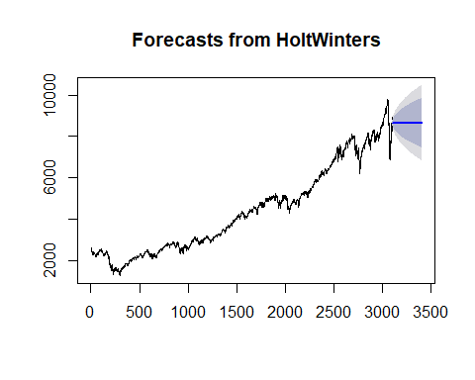 ### Evaluating Model fit and Ljung Box test

acf(TSData_forecast1$residuals, lag.max = 50, na.action = na.pass)

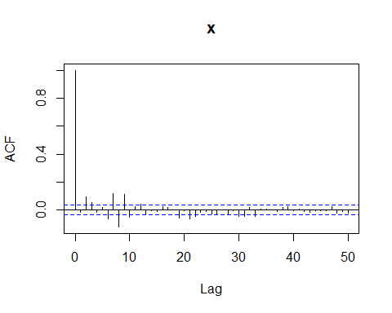

Box.test(TSData_forecast1$residuals, lag=20, type = 'Ljung-Box')

##   
## Box-Ljung test  
##   
## data: TSData_forecast1$residuals  
## X-squared = 209.2, df = 20, p-value < 2.2e-16

accuracy(TSData_forecast1)

## ME RMSE MAE MPE MAPE MASE  
## Training set 2.338896 64.36348 38.19004 0.03457671 0.9433596 1.008925  
## ACF1  
## Training set -0.01843523

### Evaluating residuals of SES

checkresiduals(TSData_forecast)

## Warning in modeldf.default(object): Could not find appropriate degrees of  
## freedom for this model.

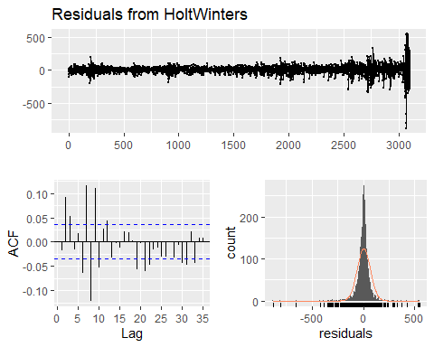

## ARIMA

### Confirming non-stationarity of the data using ACF, PACF, and Augmented Dickey-Fuller Test

library(tseries)

## Warning: package 'tseries' was built under R version 3.6.3

acf(TSData)

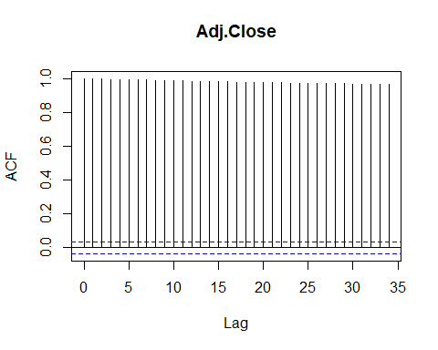

pacf(TSData)

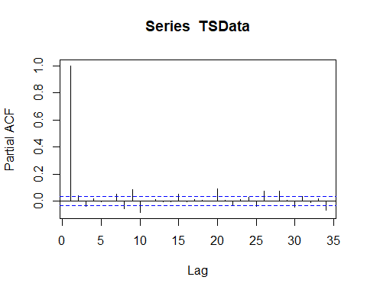

adf.test(TSData, alternative = "stationary")

##   
## Augmented Dickey-Fuller Test  
##   
## data: TSData  
## Dickey-Fuller = -3.4003, Lag order = 14, p-value = 0.05334  
## alternative hypothesis: stationary

### Making the data stationary by differentiating it to Degree one.

series1 <- diff(TSData, differences = 1)  
plot.ts(series1)

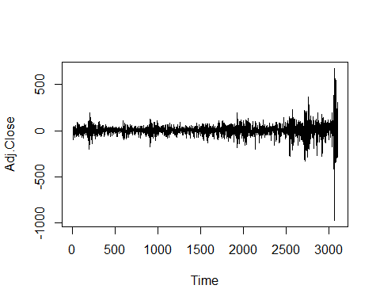

acf(series1)

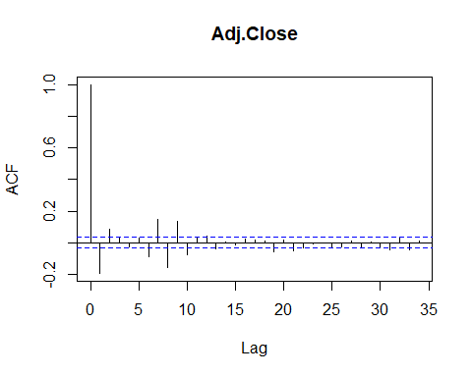

pacf(series1)

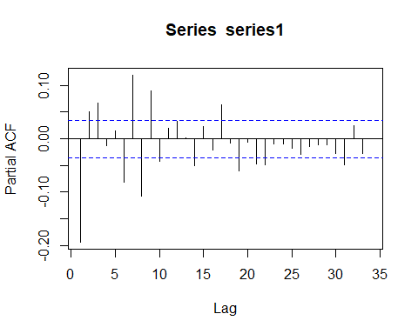

adf.test(series1, alternative = "stationary")

## Warning in adf.test(series1, alternative = "stationary"): p-value smaller  
## than printed p-value

##   
## Augmented Dickey-Fuller Test  
##   
## data: series1  
## Dickey-Fuller = -14.02, Lag order = 14, p-value = 0.01  
## alternative hypothesis: stationary

## Using Auto Arima to find appropriate parameters for p,q, d

my_arima <- auto.arima(TSData)  
summary(my_arima)

## Series: TSData   
## ARIMA(1,1,3) with drift   
##   
## Coefficients:  
## ar1 ma1 ma2 ma3 drift  
## -0.8352 0.6697 -0.0709 0.1530 1.7661  
## s.e. 0.0253 0.0296 0.0218 0.0185 1.0851  
##   
## sigma^2 estimated as 4014: log likelihood=-17262.9  
## AIC=34537.8 AICc=34537.82 BIC=34574.03  
##   
## Training set error measures:  
## ME RMSE MAE MPE MAPE MASE  
## Training set 0.1857561 63.29138 38.23935 -0.02333783 0.9467462 1.010227  
## ACF1  
## Training set -0.0031698

### Forecasting with Auto Arima

my_arima_forecast <- forecast(my_arima, h = 365)  
plot(my_arima_forecast)

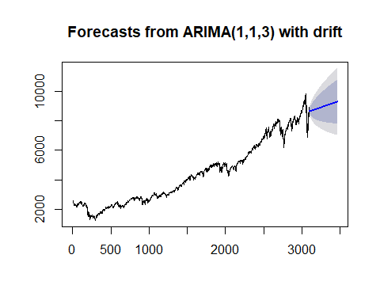 ### Checking model Fit of the auto arima

acf(my_arima_forecast$residuals, lag.max = 50, na.action = na.pass)

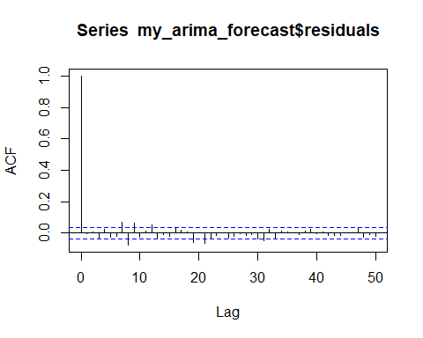

Box.test(my_arima_forecast$residuals, lag=20, type = 'Ljung-Box')

##   
## Box-Ljung test  
##   
## data: my_arima_forecast$residuals  
## X-squared = 90.064, df = 20, p-value = 7.223e-11

accuracy(my_arima_forecast)

## ME RMSE MAE MPE MAPE MASE  
## Training set 0.1857561 63.29138 38.23935 -0.02333783 0.9467462 1.010227  
## ACF1  
## Training set -0.0031698

checkresiduals(my_arima)

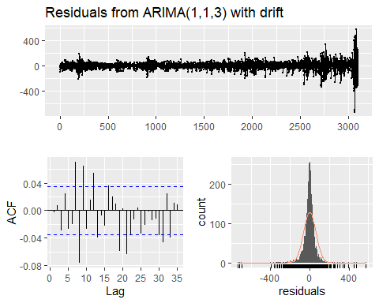

##   
## Ljung-Box test  
##   
## data: Residuals from ARIMA(1,1,3) with drift  
## Q* = 57.037, df = 5, p-value = 4.968e-11  
##   
## Model df: 5. Total lags used: 10

The Auto-Arima model is inadequate ### Looking for pdq parameter with lowest AIC for ARIMA model

record_AIC = matrix(0,7,7)  
rownames(record_AIC) = c('p=0', 'p=1', 'p=2', 'p=3', 'p=4','p=5', 'p=6')  
colnames(record_AIC) = c('q=0', 'q=1', 'q=2', 'q=3', 'q=4','q=5', 'q=6')  
for(p in 0:6){  
 for(q in 0:6){  
 m <- arima(series1, order = c(p,0,q), include.mean = TRUE)  
 record_AIC[p+1, q+1] <- m$aic  
 }  
}

## Warning in arima(series1, order = c(p, 0, q), include.mean = TRUE):  
## possible convergence problem: optim gave code = 1

## Warning in log(s2): NaNs produced

## Warning in arima(series1, order = c(p, 0, q), include.mean = TRUE):  
## possible convergence problem: optim gave code = 1

### Table of p, q and d=1 showing AIC values

library(knitr)  
kable(record_AIC,caption = 'AIC')

AIC

|  |  |  |  |  |  |  |  |
| --- | --- | --- | --- | --- | --- | --- | --- |
|  | q=0 | q=1 | q=2 | q=3 | q=4 | q=5 | q=6 |
| p=0 | 34731.90 | 34630.69 | 34598.47 | 34596.85 | 34596.49 | 34597.99 | 34591.68 |
| p=1 | 34614.64 | 34612.13 | 34598.03 | 34537.80 | 34538.28 | 34537.41 | 34522.85 |
| p=2 | 34608.73 | 34603.34 | 34597.04 | 34599.46 | 34533.39 | 34542.16 | 34469.71 |
| p=3 | 34595.95 | 34526.28 | 34600.11 | 34512.30 | 34504.96 | 34545.34 | 34463.95 |
| p=4 | 34597.40 | 34599.47 | 34530.09 | 34506.08 | 34492.98 | 34499.64 | 34472.41 |
| p=5 | 34598.68 | 34514.16 | 34489.96 | 34522.37 | 34499.54 | 34496.97 | 34455.65 |
| p=6 | 34580.12 | 34486.84 | 34478.45 | 34460.35 | 34457.55 | 34451.34 | 34500.48 |
| ### Sh | owing p q w | ith lowest | AIC at d=1 |  |  |  |  |

which(record_AIC==min(record_AIC), arr.ind = TRUE)

## row col  
## p=6 7 6

min(record_AIC)

## [1] 34451.34

### Fitting ARIMA(6,1,5)

arima2 <- arima(TSData,order = c(6,1,5))  
accuracy(arima2)

## ME RMSE MAE MPE MAPE MASE  
## Training set 1.997701 62.38348 38.49882 0.02946368 0.9586407 1.017082  
## ACF1  
## Training set -0.001223414

### Evaluating model adequacy

checkresiduals(arima2)

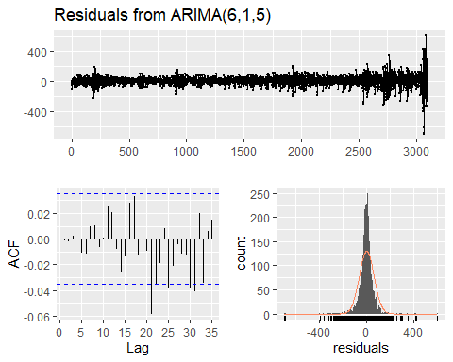

##   
## Ljung-Box test  
##   
## data: Residuals from ARIMA(6,1,5)  
## Q* = 7.2751, df = 3, p-value = 0.06363  
##   
## Model df: 11. Total lags used: 14

### Forecasting With ARIMA(6,1,5)

arima2_forecast <- forecast(arima2, h=365)  
plot(arima2_forecast)

